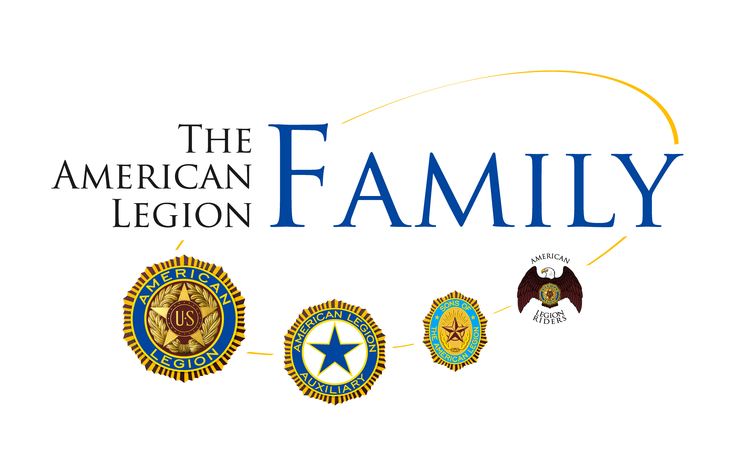
Official Program

Tenth District Spring Conference

Saturday, June 2, 2012
Des Moines, IA

Meetings held at:
The American Legion of Iowa
720 Lyon Street
Des Moines, IA 50309

Hosted by Post & Unit #729

Hospitality:
Friday, June 1
Post Home
6:00-9:00 pm

Motel Reservations:
Holiday Inn Airport
6111 Fleur Drive
Des Moines, IA 50309
(515) 287-2400

“Lead the Legacy”
“Remembered Not Forgotten”
The American Legion
10th District Spring Conference

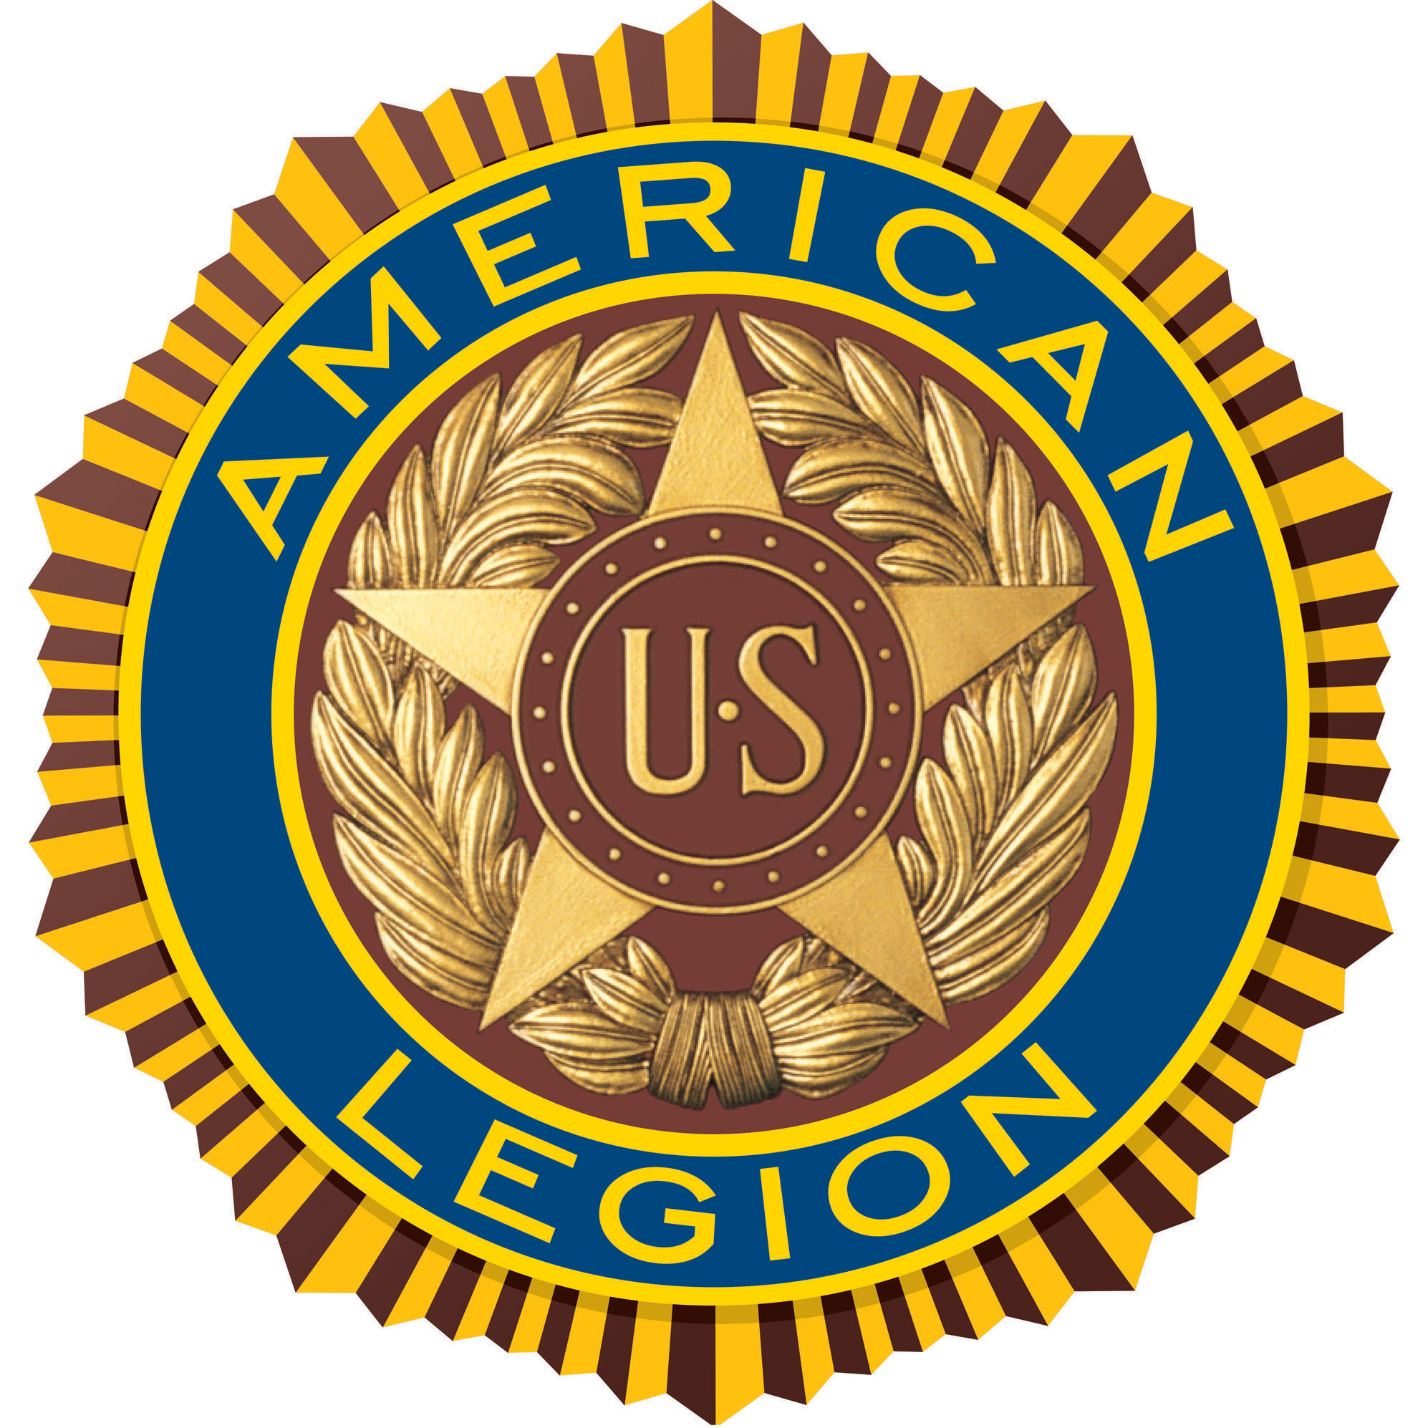
The American Legion Morning Session
7:30 – 8:45 Registration & Coffee
8:00 Executive Board Meeting
9:00 Conference Convenes
Call to Order District Commander
Advancement of Colors Post #729
Invocation Chaplain
POW/MIA Sergeant-at-Arms
Pledge of Allegiance All
Preamble All
Roll Call Adjutant
Minutes Adjutant
Financial Report Finance Officer
Rules of Conference Judge Advocate
Introduction of Guests Commander
Department Remarks:
SAL Detachment Commander Bob Rosenboom
Dept. Membership Chairman Jim Demarest
Department Service Officer Rich Anderson
Department Adjutant John Derner
NEC John Ross
Department Commander Dennis Soppe
Announcements District Commander
11:15 Recess
11:30 Memorial Service
12.00 Banquet
The American Legion Afternoon Session
1:00 Reconvene
District Chairman Reports:
Americanism Joylyn Steinfadt
Athletics & Contests Claude Smith
Baseball - Senior Richard Meiners
Baseball – Youth Robert Hill
Boy Scouts John S. Moline
Boys State Dennis Hanna
Children & Youth Harlan Backhaus
Community Service Allan Johnston
Junior Shooting Sports Darwin Rossander
Oratorical Ron Struble
Internal Affairs Mel Goslar
Membership Jim Demarest
S.A.L. Advisor Gary Haverman
Legion Riders Robert Wenger
Legislative Elizabeth Ledvina
National Affairs Dennis Fritz
VA&R Ron Tyne
Convention Jerry Sebben
Foundation Carroll Wegner
Liaison Louis Kirk
Old Business
Election of Officers
Election of Delegates to National Convention
New Business
Time and Place
For the Good of The American Legion
Benediction District Chaplain
Retirement of Colors Post 729
Adjourn
American Legion Department Officers
Commander Dennis Soppe
NEC John Ross
Alternate NEC Bruce Feuerbach
Vice Commander Monte Railsback
Vice Commander Floyd Proctor
Vice Commander Ted Hall
Vice Commander Thomas Henderson
Vice Commander Don Rasmussen
Adjutant John Derner
Finance Officer Ken Danilson
Judge Advocate Walt Saur
Historian Seth Bartmess
Chaplain Dan McClure
Service Officer Rich Anderson
Sergeant-at-Arms James Meyer

American Legion 10th District Officers
Commander Dennis Soppe
NEC John Ross
Alternate NEC Bruce Feuerbach
Vice Commander Monte Railsback
Vice Commander Floyd Proctor
Vice Commander Ted Hall
Vice Commander Thomas Henderson
Vice Commander Don Rasmussen
Adjutant John Derner
Finance Officer Ken Danilson
Judge Advocate Walt Saur
Historian Seth Bartmess
Chaplain Dan McClure
Service Officer Rich Anderson
Sergeant-at-Arms James Meyer
Preamble to the Constitution of
The American Legion
For God and Country, we associate ourselves together for the following purposes: To uphold and defend The Constitution of the United States of America; To maintain law and order; To foster and perpetuate a one hundred percent Americanism; To preserve the memories and incidents of our associations in All Wars; To inculcate a sense of individual obligation to the community, state and nation; To combat the autocracy of both the classes and the masses; To make right the master of might; To promote peace and good will on earth; To safeguard and transmit to posterity the principles of Justice, Freedom and Democracy; To consecrate and sanctify our comradeship by our devotion to mutual helpfulness.

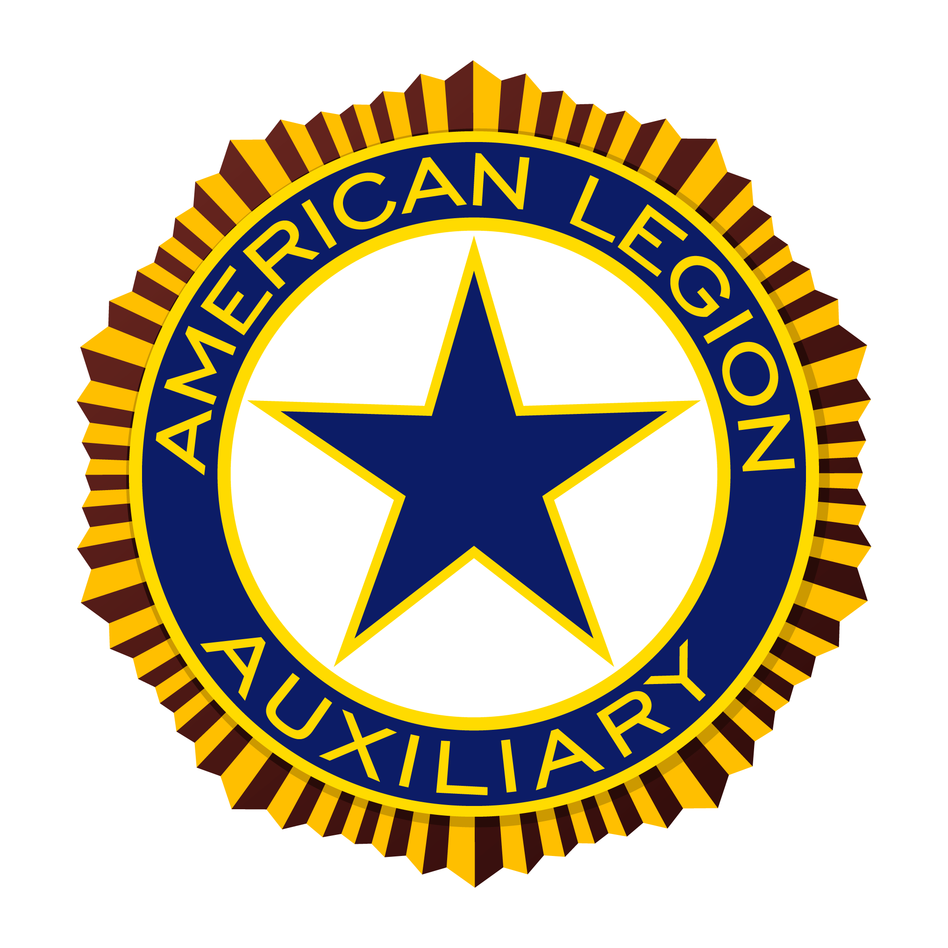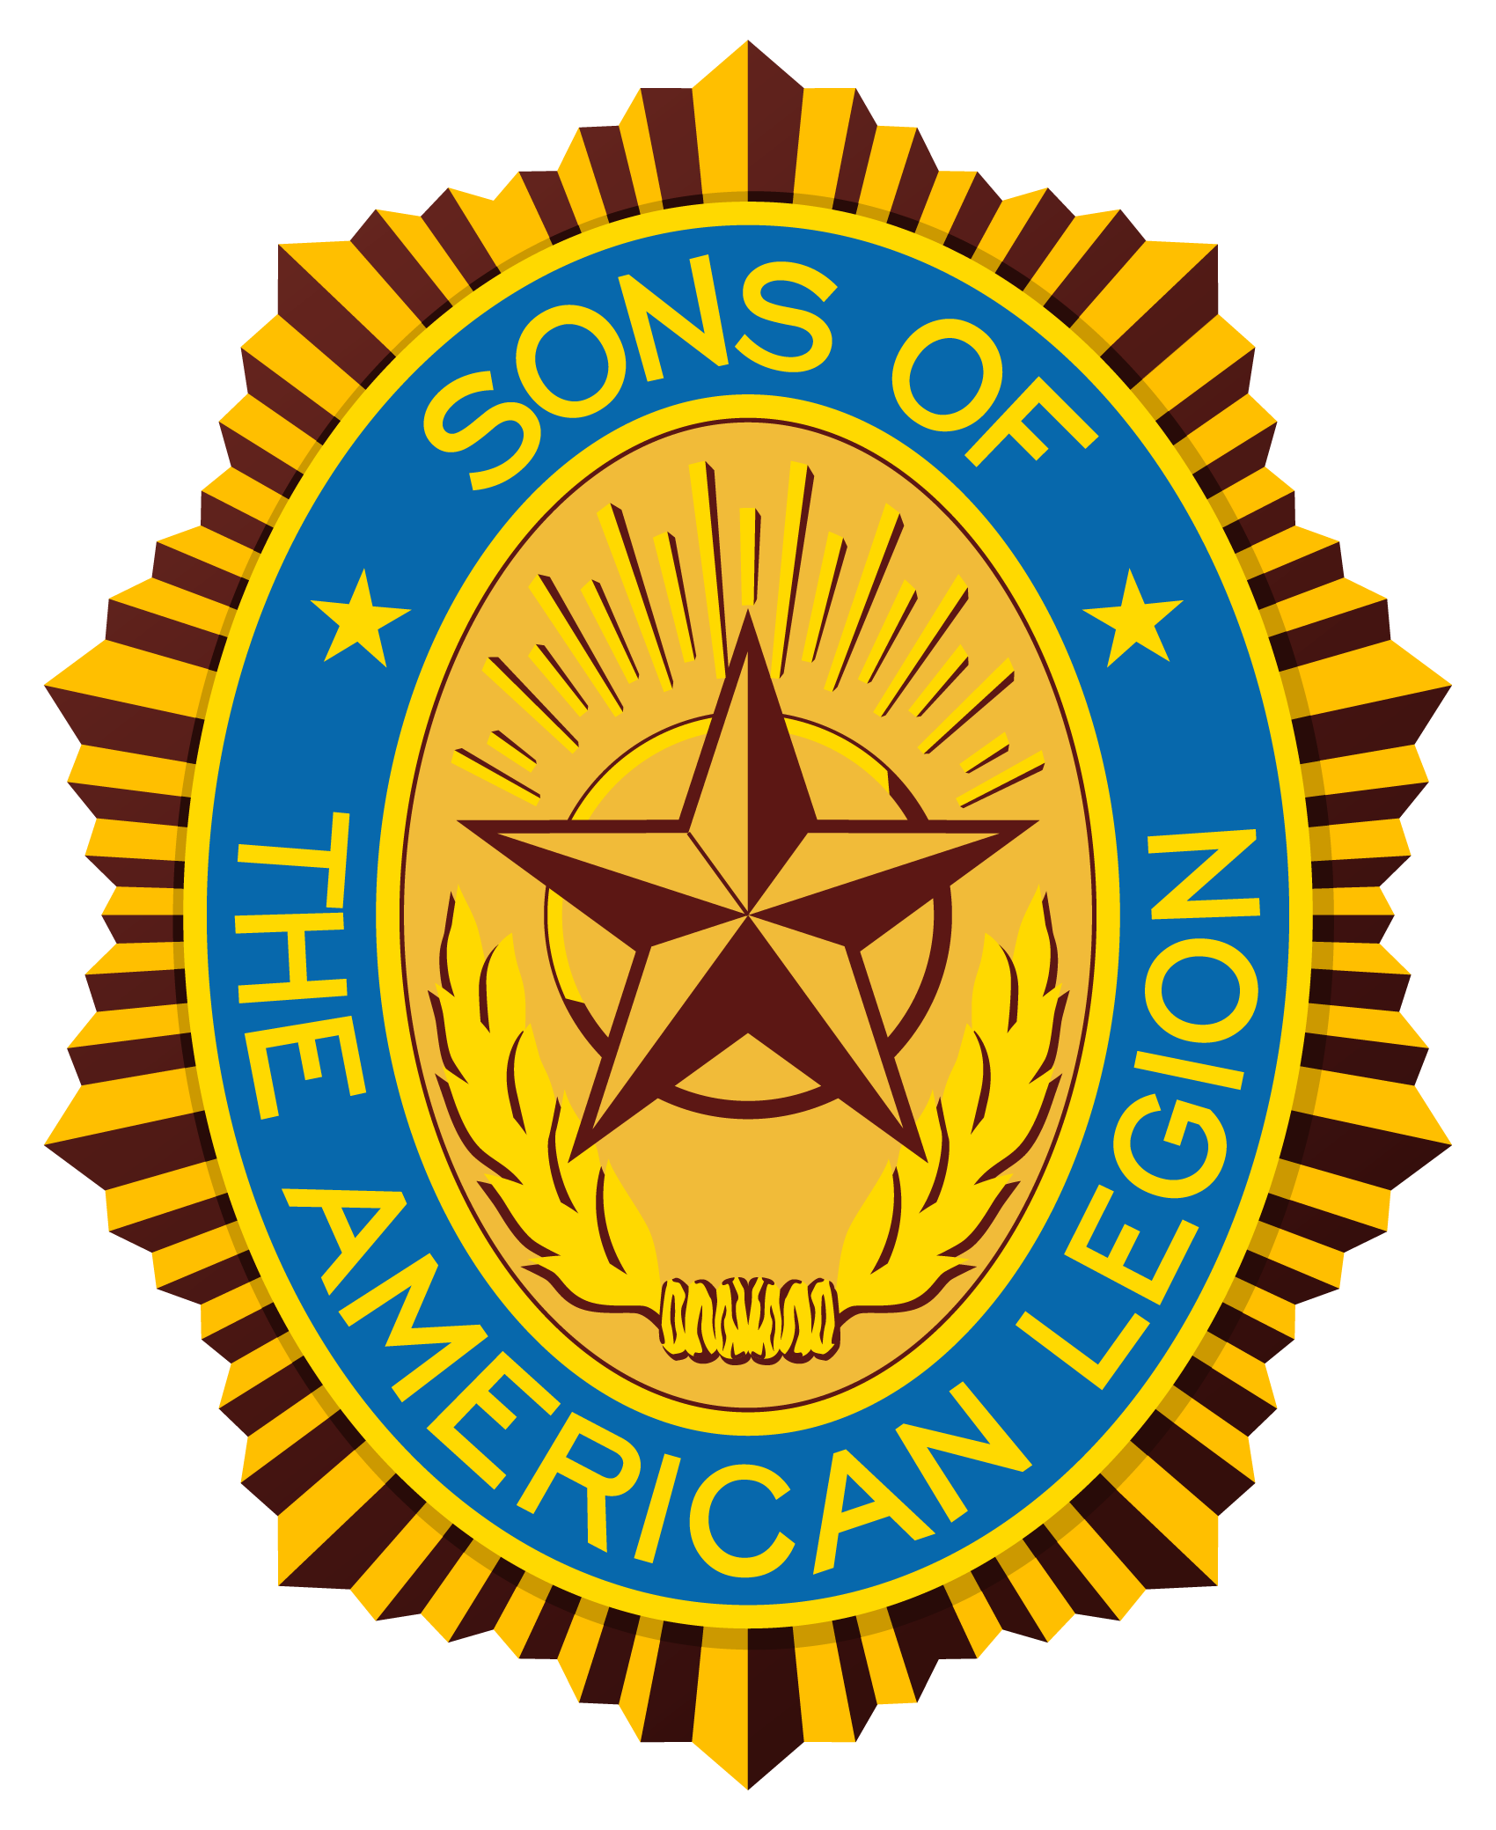

Banquet Program
Memorial Service District Chaplain
Salute to Colors District Commander
Invocation Auxiliary District Chaplain
Welcome Mayor
Lunch
Introduction of Legion Guests Commander
Introduction of Auxiliary Guests President
Address Bob Rosenboom, Detachment Commander
Address Martha Travis, Department President
Address Dennis Soppe, Department Commander
Benediction Legion District Chaplain
Salute to Colors District Commander

American Legion Auxiliary
10th District Spring Conference

American Legion Auxiliary Morning Session
8:00 Registration & Coffee
8:00 Page Practice
8:15 Executive Board Meeting
8:45 Processional Line-Up
9:00 Conference Convenes
Call to Order District President
Advancement of Colors District Pages
Processional Past Presidents & Officers
POW/MIA Flag
Invocation Chaplain
Pledge of Allegiance All
National Anthem
Preamble All
Welcome Local Unit
Response Vice President
Minutes Secretary
Roll Call Secretary
Treasurers Report Treasurer
Nominations
Introduction of Guests President
Department Remarks:
Department Membership Mary Sebben
Department Secretary Marlene Valentine
Department President Martha Travis
11:15 Recess
American Legion Auxiliary Afternoon Session
1:00 Reconvene
District Chairman Reports:
Americanism Jayne Soppe
Auxiliary Emergency Fund Vickie Klinkhammer
Children & Youth Twilah Raes
Community Service Judy Demarest
Constitution & By-Laws Betty “Tooter” Baker
Education Carol Walthart
Girls State Wendy Riggle
Chaplain, Gold Star & Memorial Cindy Meyer
Junior Activities Jackie Tyne
Junior Camp Michelle Copple
Leadership Mary Littrell
Legislation Vera Collins
Membership Mary Sebben
National Security Marilyn Block
Past Presidents Parley Fran Kirk
Poppy Tammy Richardson
Public Relations Ann Crawford
Veterans Affairs & Rehabilitation Diana Shadduck
Home & Field Service Sharon Anderson
Historian’s Report Constance Schlitter
Old Business
Election of Officers
Election of Delegates to National Convention
New Business
Benediction District Chaplain
Retirement of Colors District Pages
Adjourn
American Legion Auxiliary Department Officers
President Martha Travis
Vice President Ann Crawford
President Elect Mary Littrell
Secretary/Treasurer Marlene Valentine
Chaplain Cindy Meyer
Historian Lois Slaba

American Legion Auxiliary 10th District Officers
President Martha Travis
Vice President Ann Crawford
President Elect Mary Littrell
Secretary/Treasurer Marlene Valentine
Chaplain Cindy Meyer
Historian Lois Slaba

Preamble to the Constitution of
the American Legion Auxiliary
For God and Country, we associate ourselves together for the following purposes: To uphold and defend The Constitution of the United States of America; To maintain law and order; To foster and perpetuate a one hundred percent Americanism; To preserve the memories and incidents of our associations during All Wars; To inculcate a sense of individual obligation to the community, state and nation; To combat the autocracy of both the classes and the masses; To make right the master of might; To promote peace and good will on earth; To safeguard and transmit to posterity the principles of Justice, Freedom and Democracy; To participate in and contribute to the accomplishments of the aims and purposes of The American Legion; to consecrate and sanctify our association by our devotion to mutual helpfulness.

